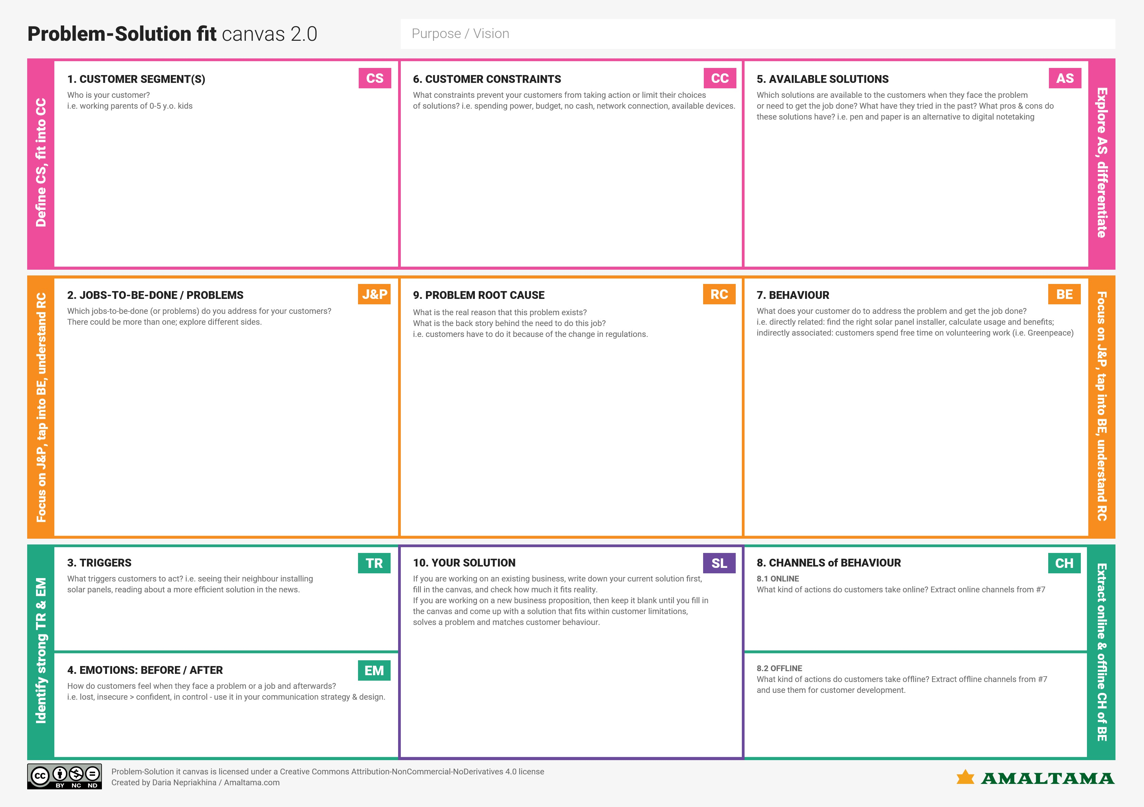

User should proceed with proper health care after the prediction.

Have a stable internet connection and use Google chrome, Firefox, etc..

Solution aims to predict the presence of heart disease with the help of user friendly interface. Machine learning model is used to improve the accuracy of the result.

Electronic devices such as laptops, tablets or mobiles are needed to use our prediction system.

Disease can be predicted with the existing method but the results may not be accurate.

The ability to predict risk for and from cardiovascular disease is increasingly important for several reasons. Perhaps foremost among these is the need to determine individual risk to better plan investigation and management with the greatest accuracy and safety for patients and lowest costs for thehealth caresystem.

* Network connection may cause trouble.
* User may not know the needed inputs for prediction.
* Laptop or mobile need to be available.

**Before – Not sure about the symptoms, fear about their well being**

**After – Can predict the presence of the disease, taking proper medication**

User can predict the presence of heart disease with increased efficiency and accuracy

To build a machine learning model to predict the possibility of heart disease in user with high accuracy with the help of the some of the attributes such as:

* Chest pain type
* Blood Pressure
* Max HR
* Exercise angina

People who sense symptoms related to any heart diseases. Symptoms including chest pain, chest pressure, shortness of breath, pain, etc..